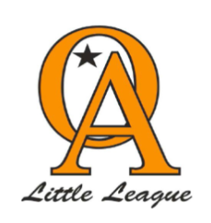
Orcutt American Little League
Minor 2024 League Rules

- Home team will set up the field and the visiting team will break down and clean up the field. This included emptying the trash cans.

- Home team is in charge of scorekeeping. Scorekeeper to arrive 15 mins prior to game time.

- Every player on the roster will participate for a minimum of 50% of the game and the continuous batting order of all players on the roster will be used. Players cannot sit on the bench for more than one inning in a row.
  - Note the exceptions are as follows:
    - Injured players or those being disciplined, all known exceptions must be noted in the official score book before the start of the game. Player agent must be notified of disciplinary action against the player prior to action being taken.

- During weekdays the time limit is 1hr and 45 minutes. Saturday's game time limit is 2 hours. No new inning once the time limit has expired.

- 5 run limit per inning except for the final inning (unlimited runs). Umpire to determine final inning.

- Home plate will be closed to passed balls for the first 6 games. The only way a runner can advance to home is on a hit by the batter or walk with bases loaded.
- After the 6th game of the season home plate is open on passed balls and runners on 3rd base may advance on a passed ball.
- Time permitting 6 innings will be played.
- The 10 run rule will be imposed on all games after the 4th inning.
- No time limit and 6 innings to be played in the minors championship game. The run rule is still in effect.
- Rescheduled games due to weather or any other board approved reason will be rescheduled on the next available Friday.
- There may be a courtesy runner for the pitcher and catcher when there are two outs. Courtesy runner must be the player in the batting order who made the last out.
- Pitchers that hit 3 players in a game will be removed from pitching in that game.
- Once a pitcher is removed by a coach he may not reenter that game as a pitcher.
- Games to be decided by score at the bottom of the last inning played.
- Win/Loss records will be tracked to determine end of season tournament seeding.
- The umpires are the final say for games called in darkness/weather.
- Minors shall use a plan A draft method/serpentine draft

